**PROCESS AUTOMATION USING PROCESS BUILDER IN**

**SALESFORCE**

**AIM:**

To create a Process Automation using Process Builder tool in Salesforce to

control the order of actions or evaluate the criteria for a record when it is created or

updated.

**PROCEDURE:**

**STEP 1 :** Log in to your Salesforce developer account.

**STEP 2 :** Then, go to **"Set Up"**. You will see **"Quick Find".** In the Quick Find

dialog box,Type **"Process Builder".**

**STEP 3 :** You will now see the Process Builder Wizard. Click on **"New"** button to

create a new process builder.

**STEP 4 :** In this step, you will need to fill the following details:

* Process Name: Job_Status
* Description: Job Applicant Status
* From the drop-down menu, select "A Record Changes".
* Then, click on "Save" button.

**STEP 5 :** Then, you will see a **“Flow Diagram”** in your process builder page.

* In the flow diagram, you will see a form on the right-hand side.
* Select the object name as **"Job"**. Then click **“SAVE”.**
* Then, choose the option to start the process as **"When a record is created or**
* **edited".** Then click on "Save" button.

**STEP 6 :** Now Select **"Add Criteria".**

* In Criteria Name, enter Step 1: Log in to your Salesforce account.
* Next, choose Criteria for Executing Actions as "Conditions are Met".
* Then, you need to set the condition field as Job_Status=='Selected'. Then click on "Choose" button
* Next, you will need to click the + operator symbol to choose the Job_status field picklist value as "Selected".
* Next, Click on "Immediate Actions".
* Next, Click on "Immediate Actions" to be performed when a criterian is met. (In our case we have taken Email-alert and field update as two criterias).

(Note:Create a new E-mail template to prepare the mailing subject and body

of the message. Then, create a new E-mail alert and include the email-

template. The include the email alert API name in process builder.

**STEP 7 :** Finally click on "Activate" button.

**STEP 8 :** Hence, when you update or edit a record (ie.,in our case Job_Status field

update), you will receive an automatic E-mail alert.button.

**OUTPUT:**

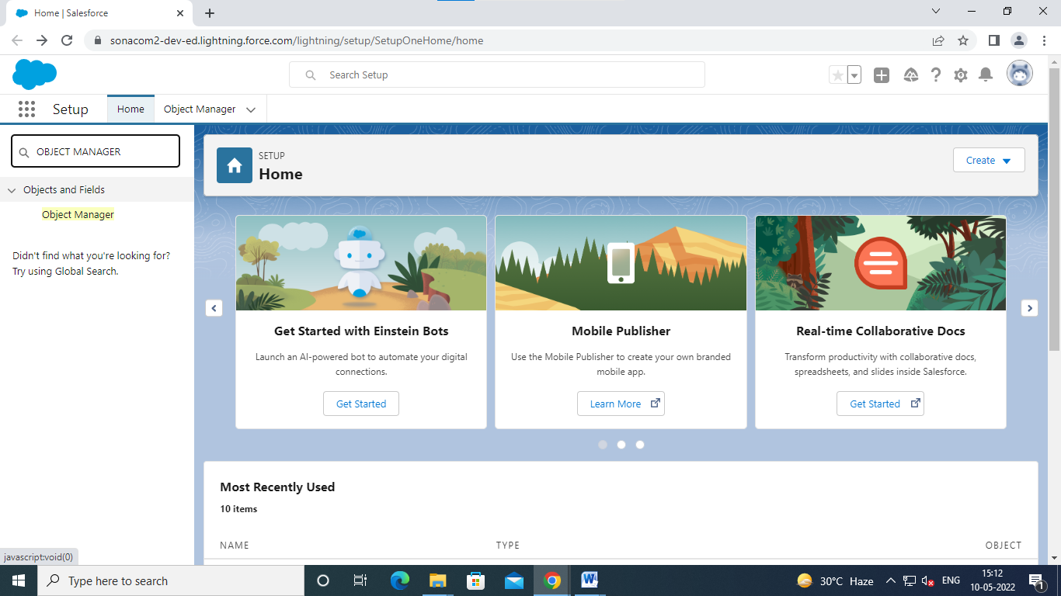

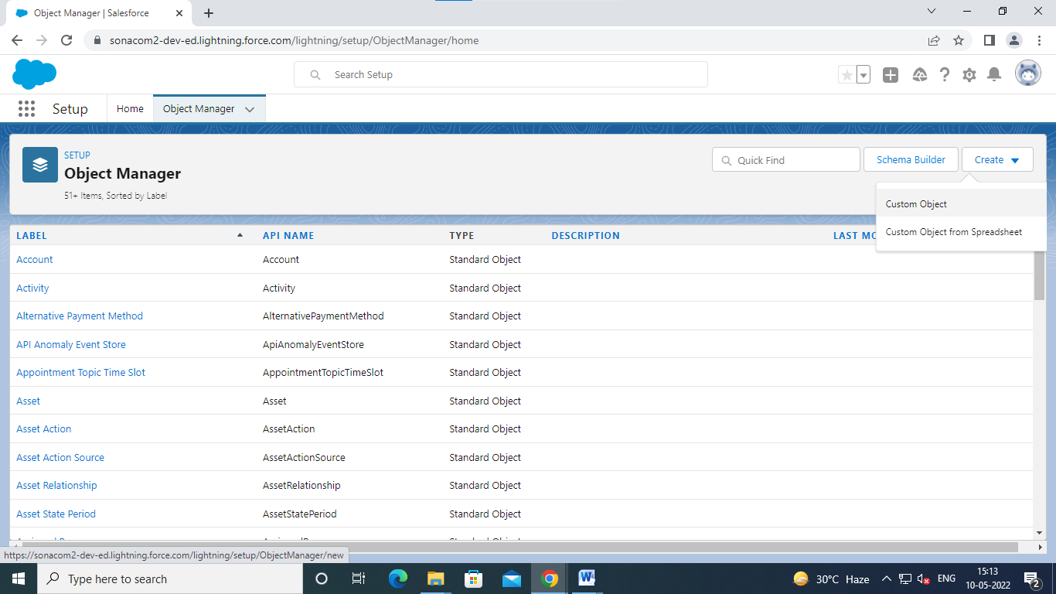

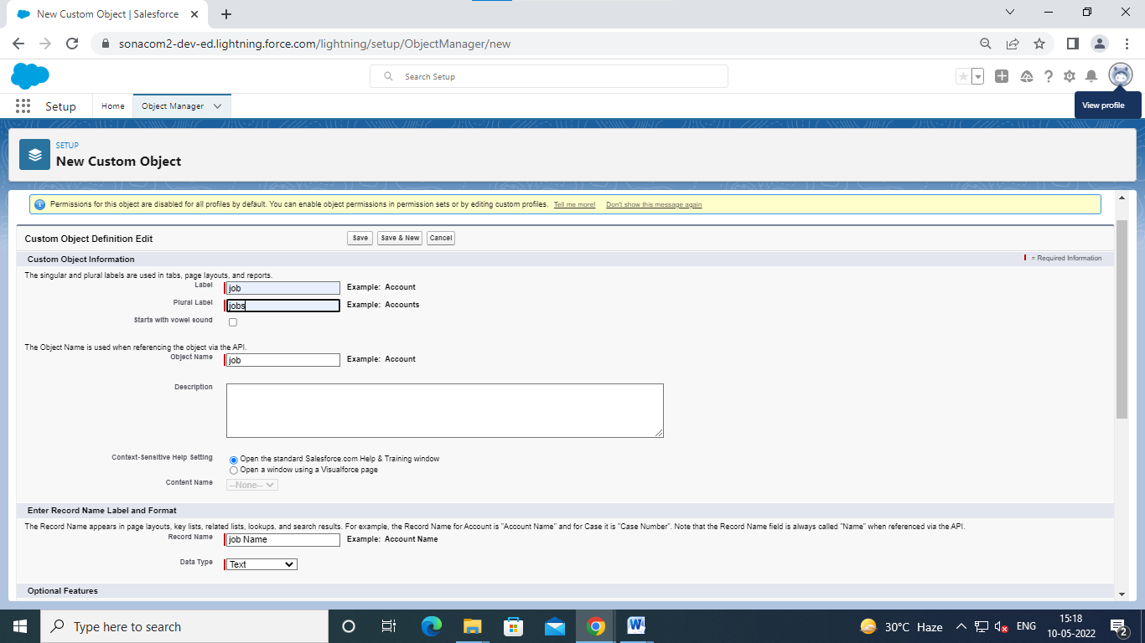

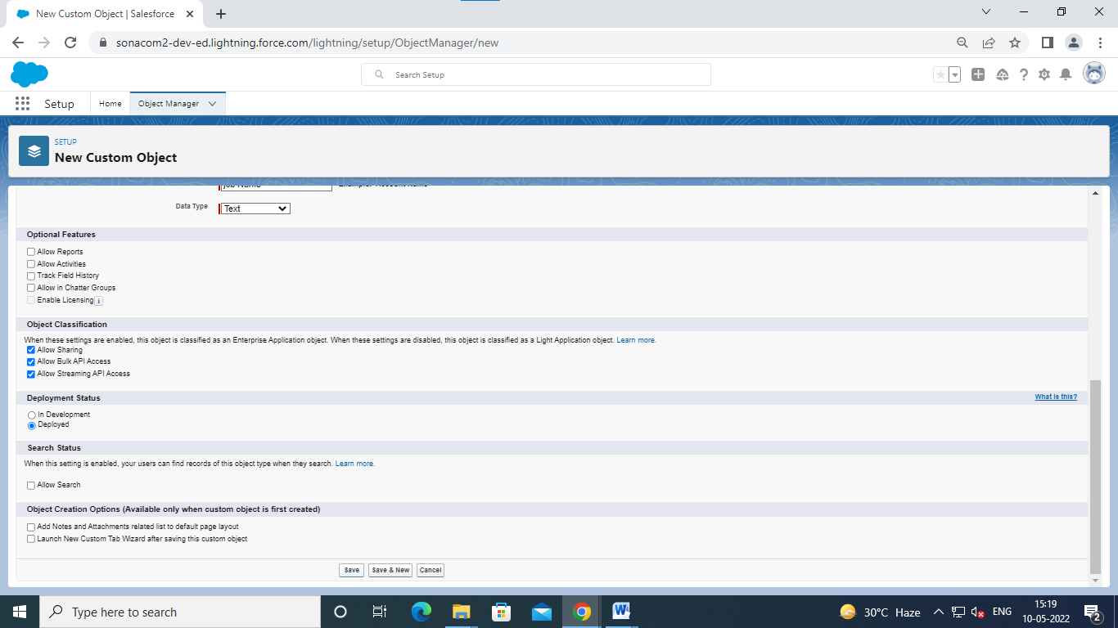

Click save

.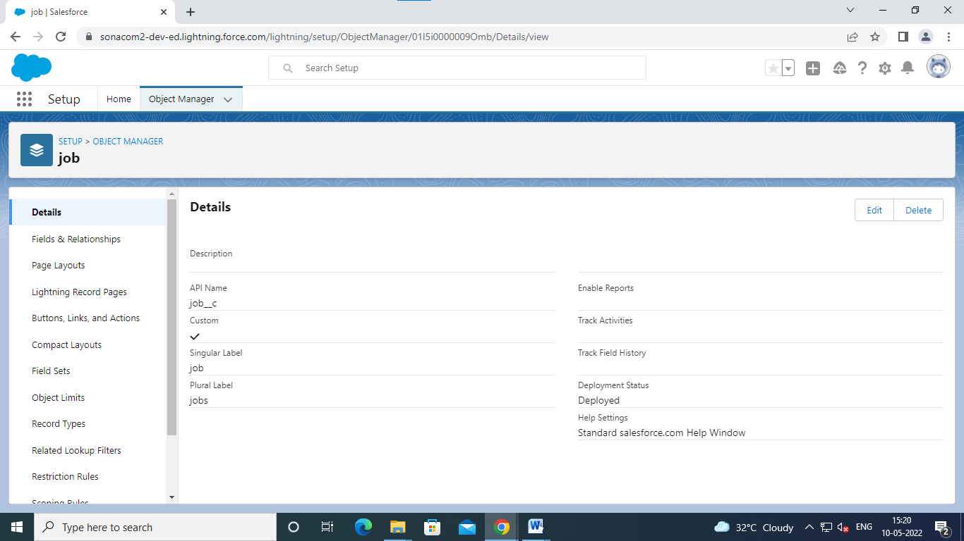

Click fields and relationship

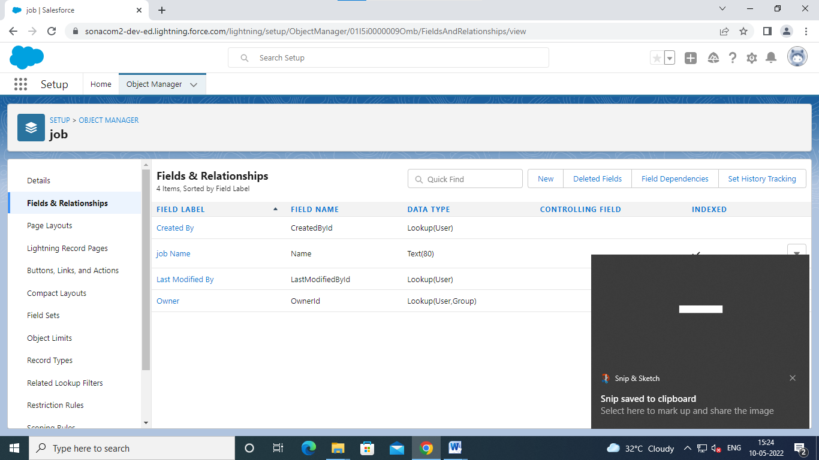

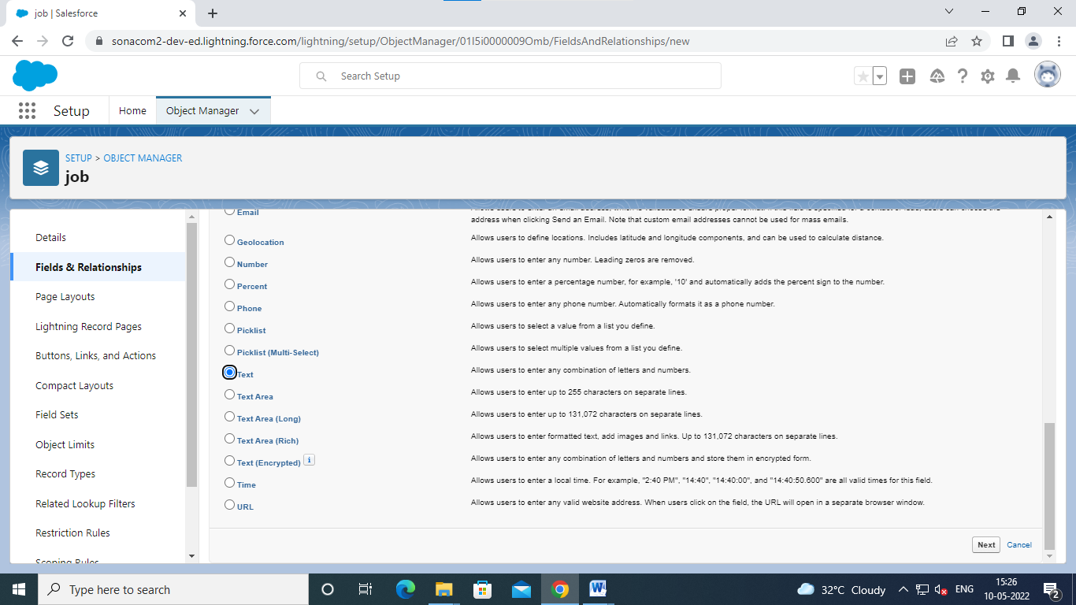

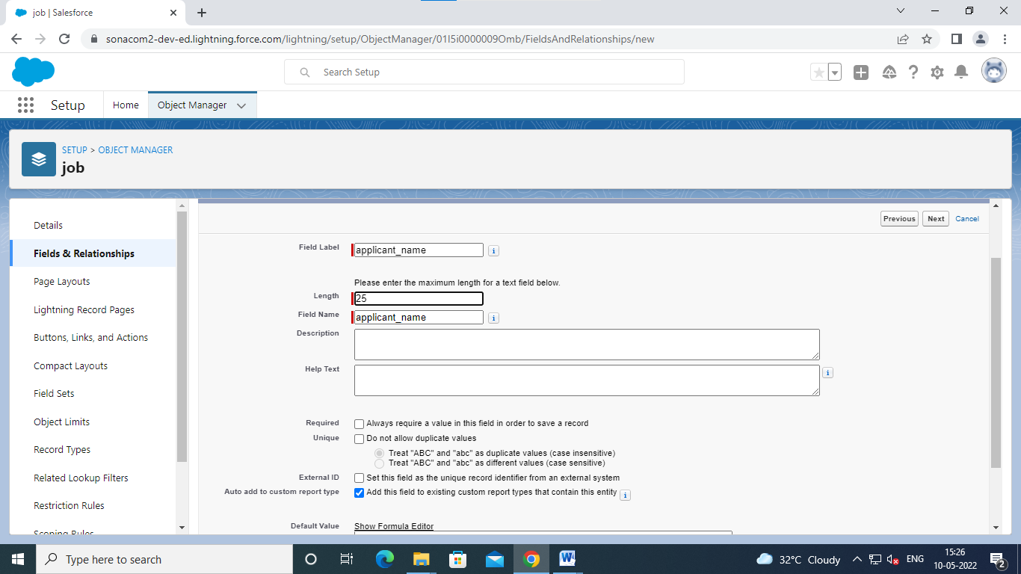

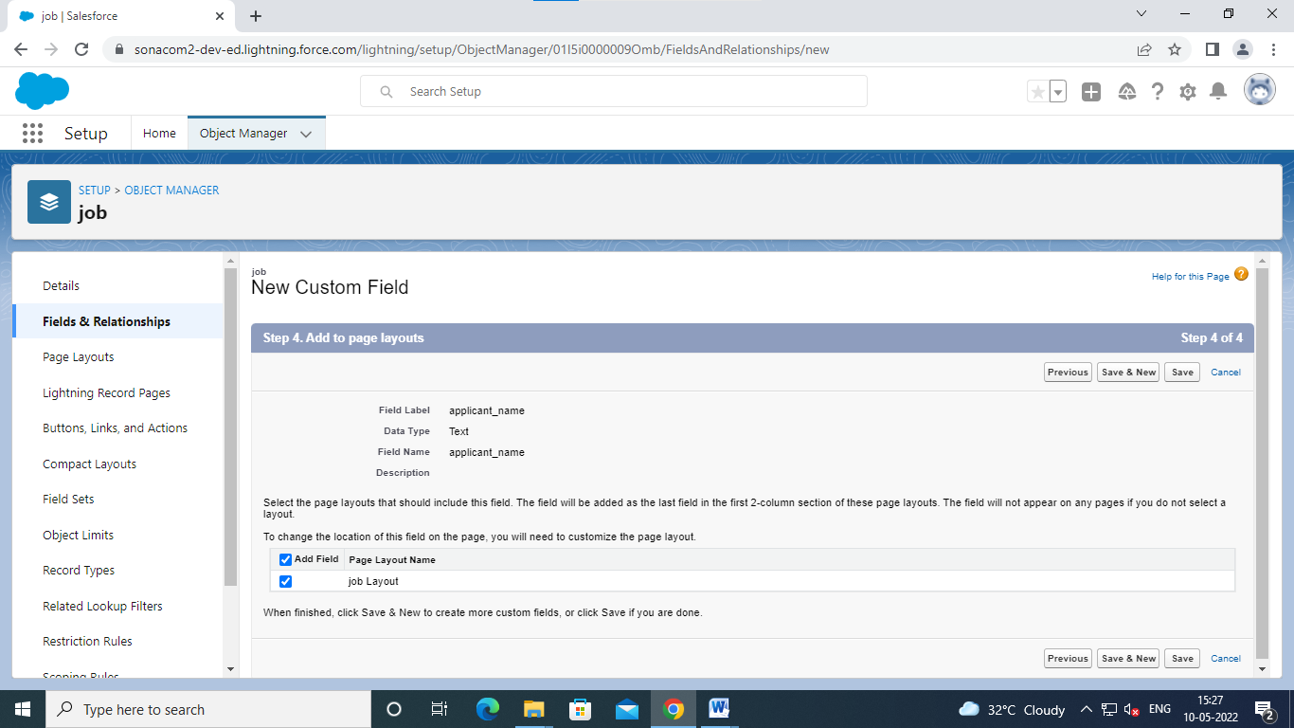

Click save andnew

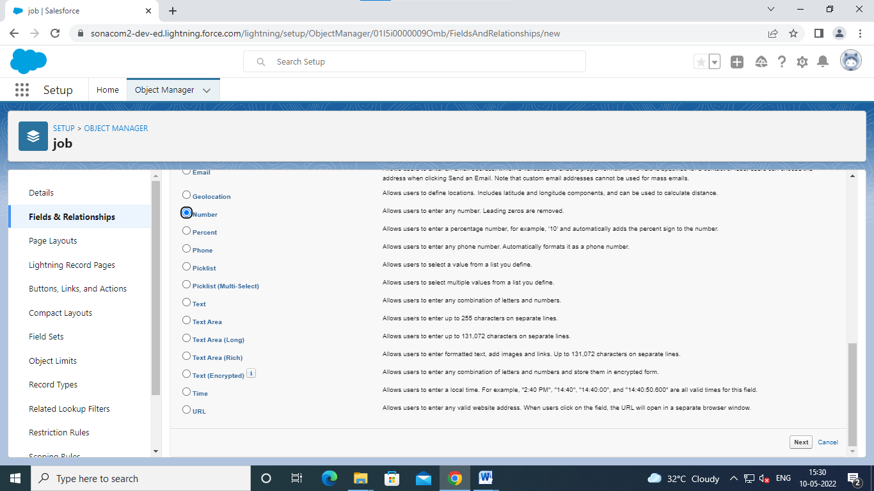

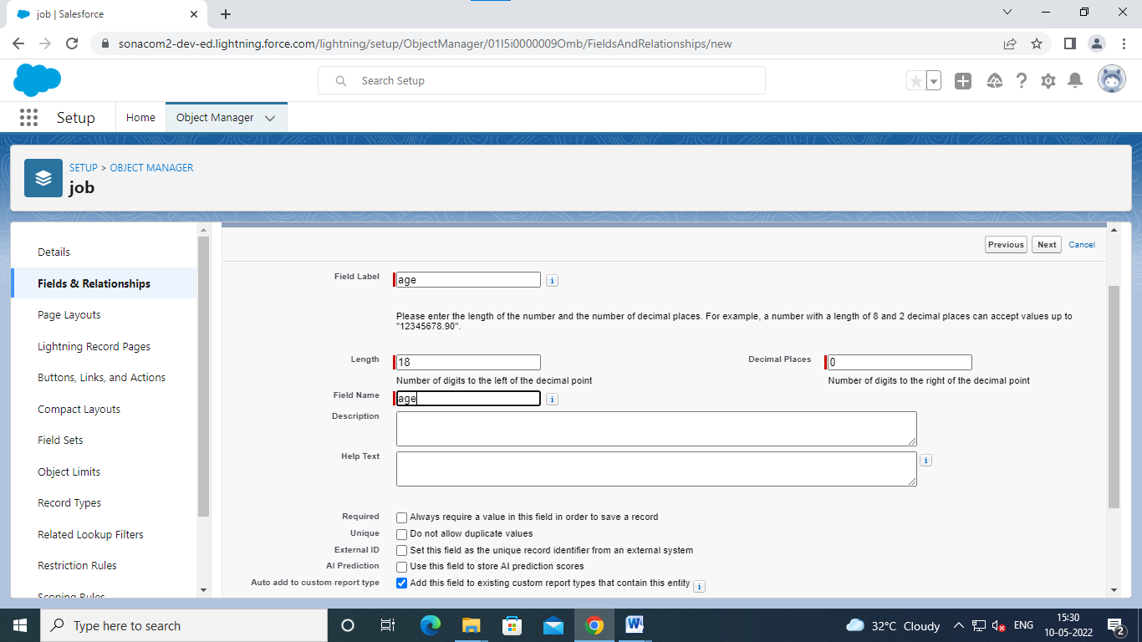

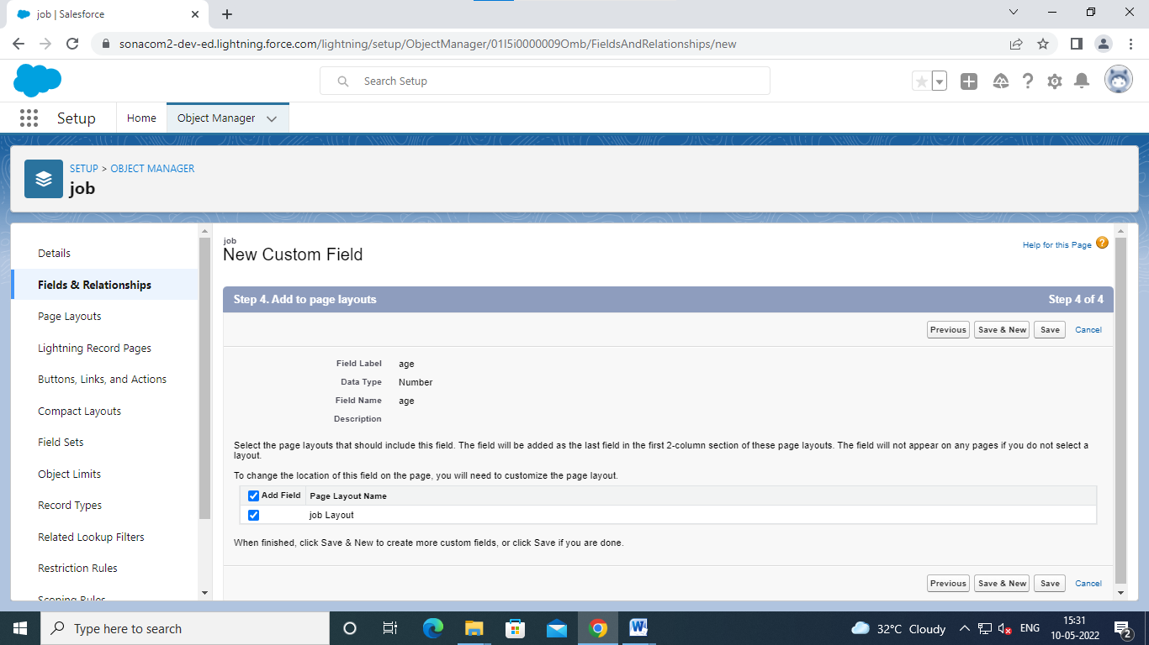

Click save and new

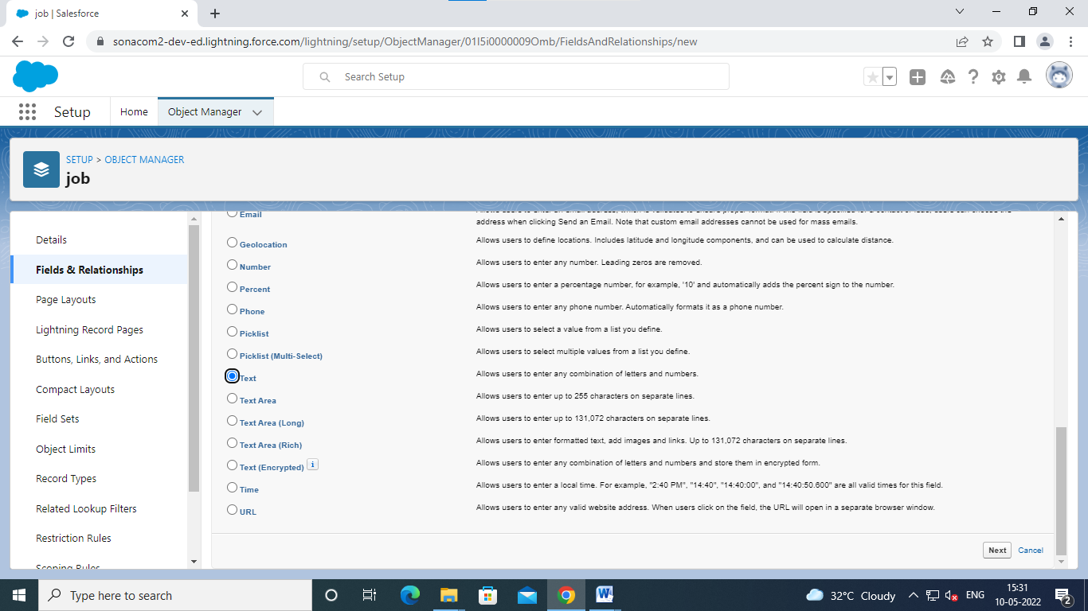

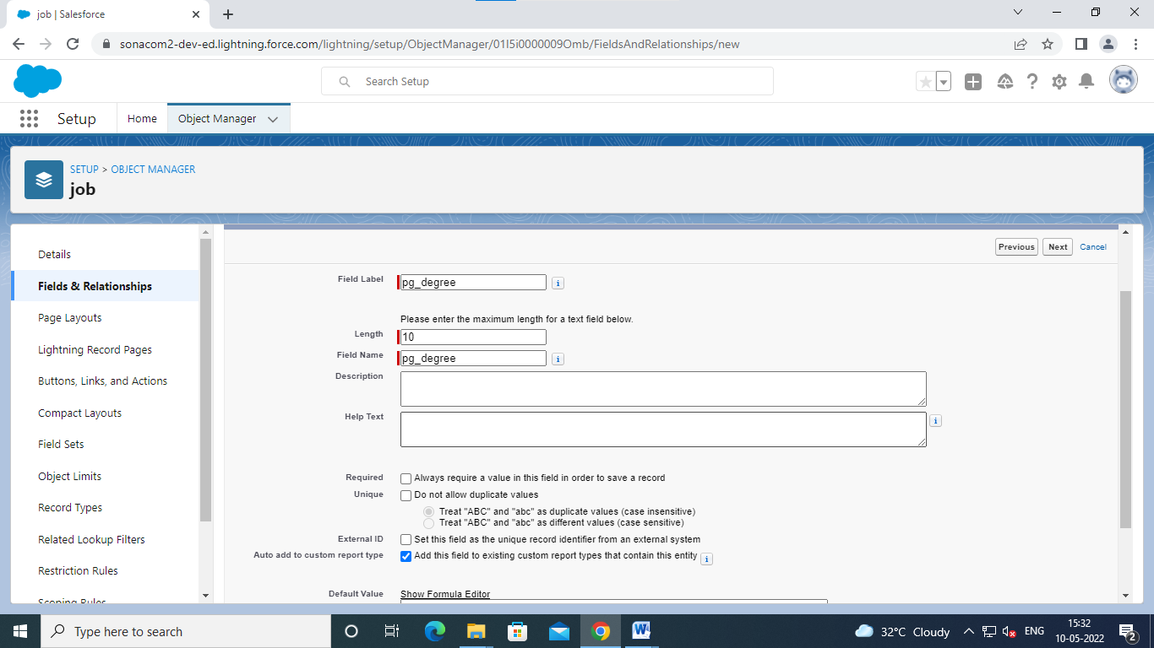

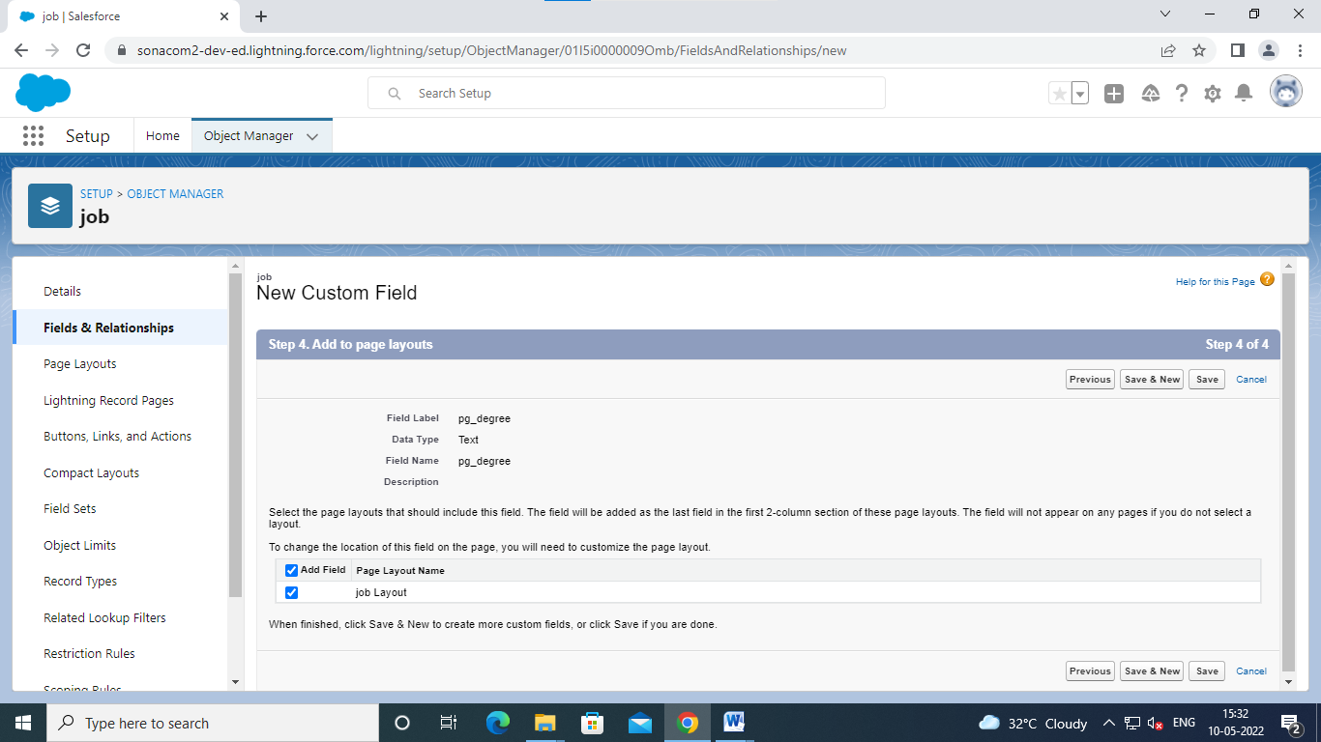

Click saves and new

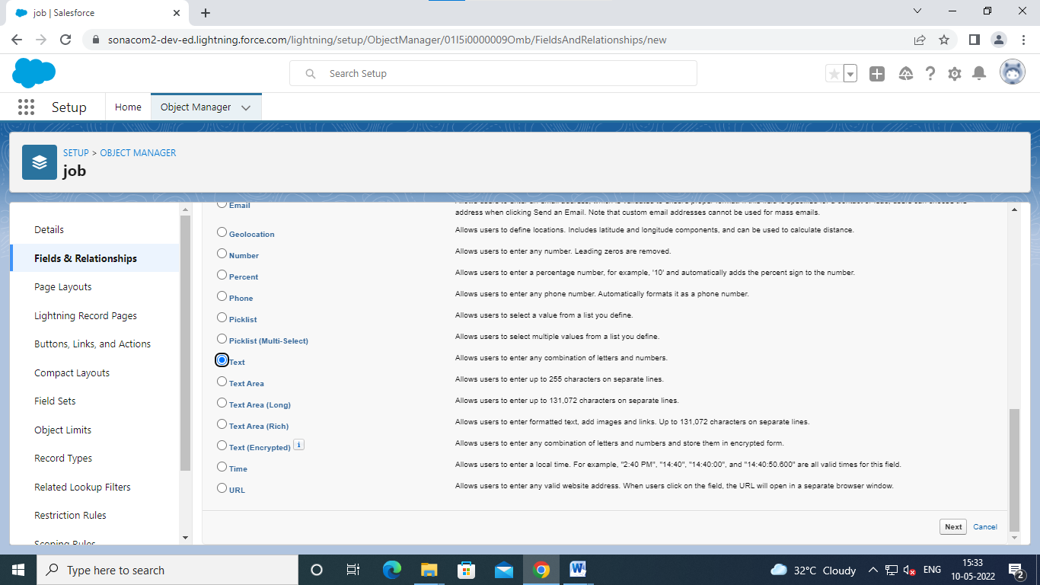

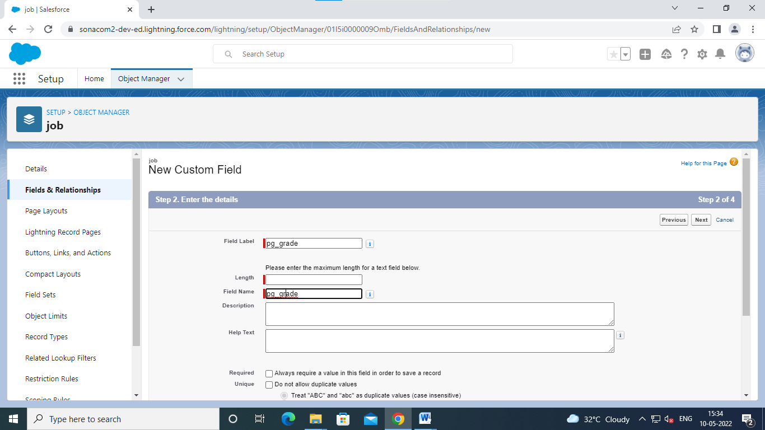

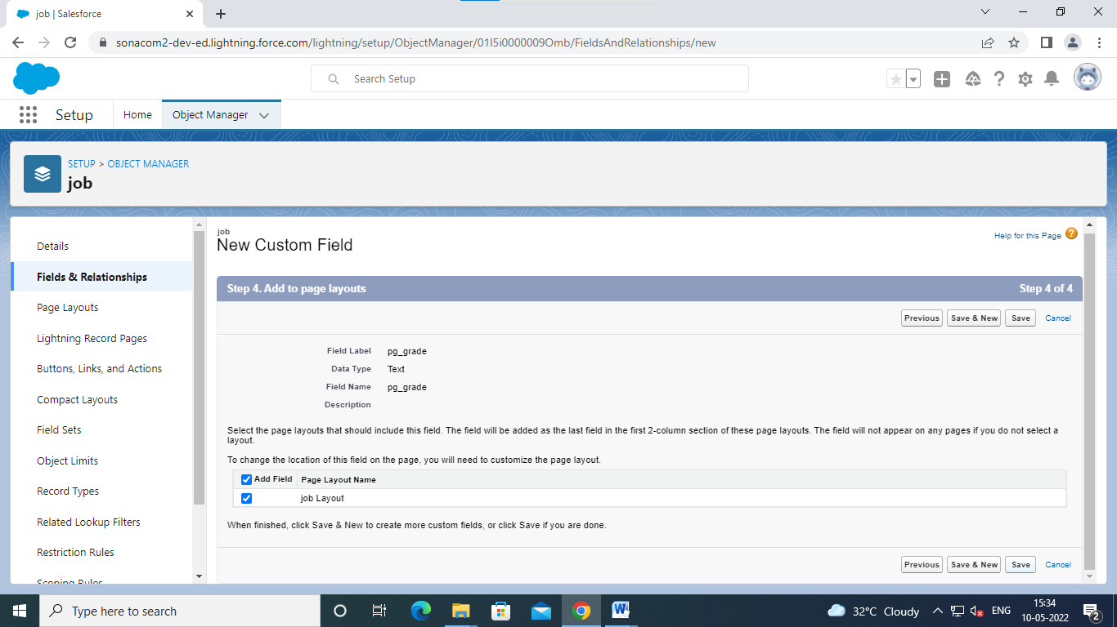

Click saves and new

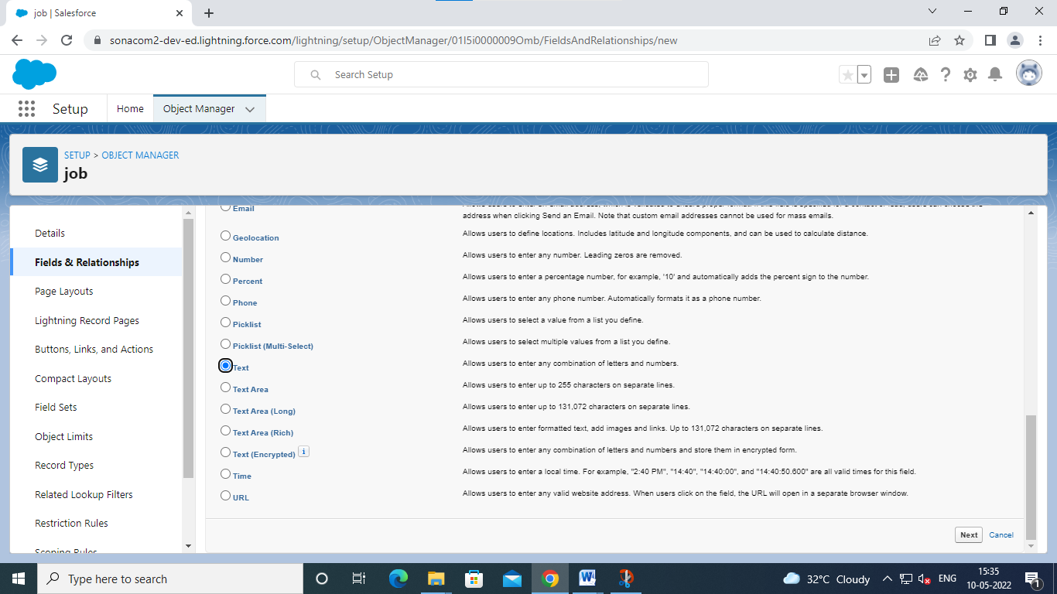

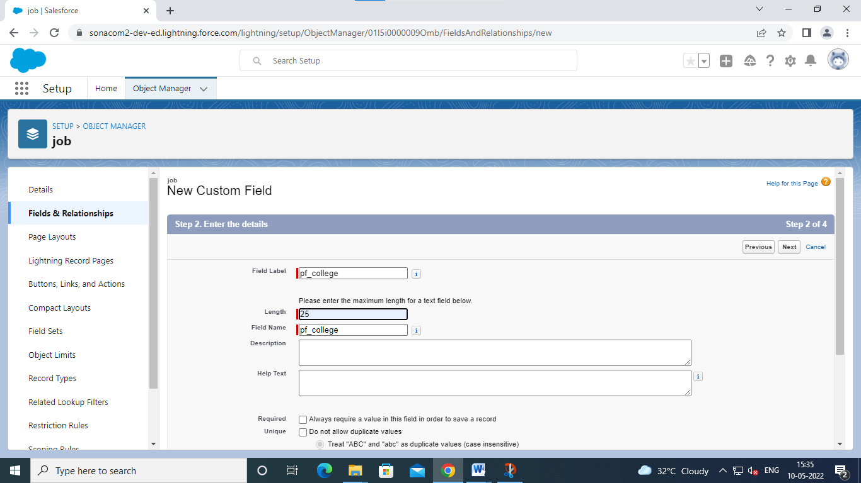

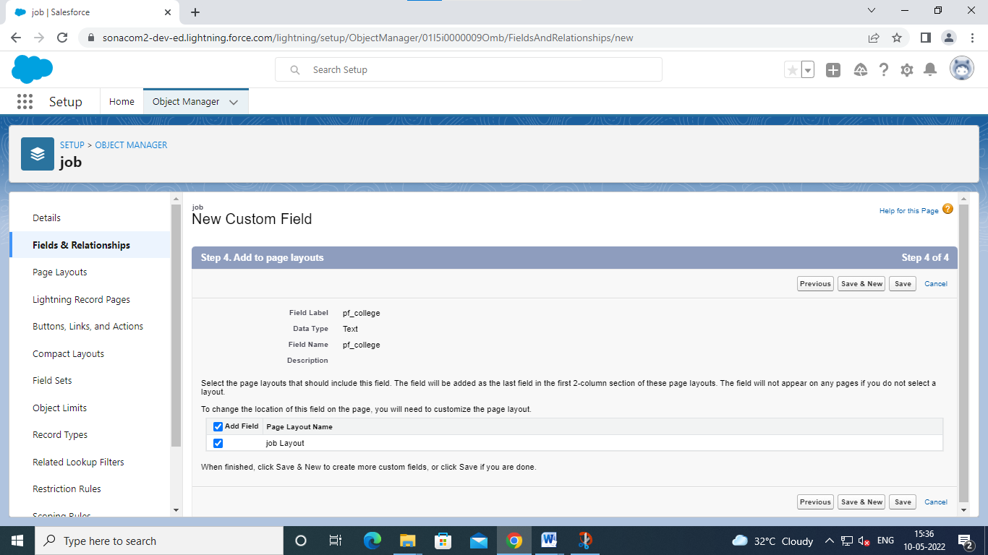

Save and next

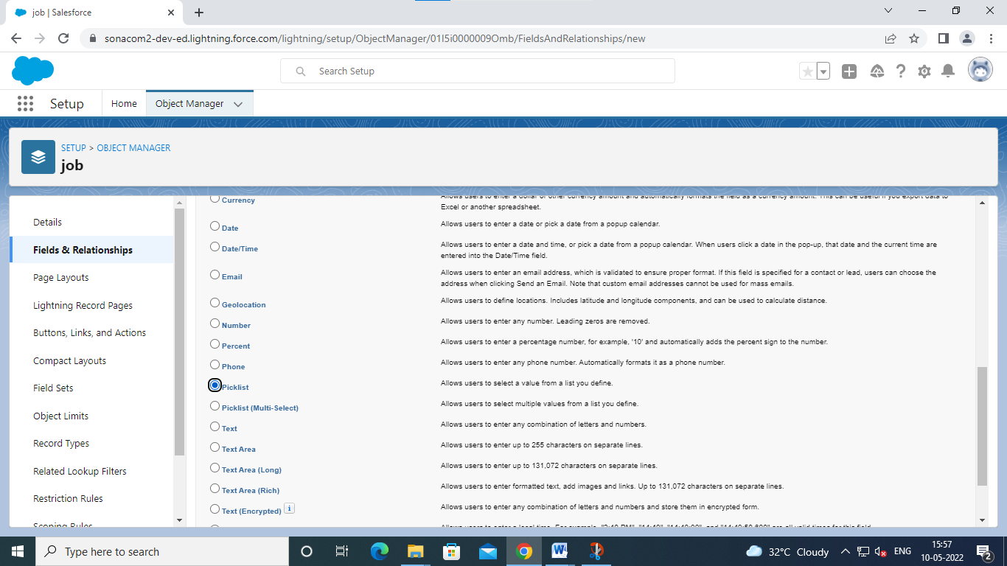

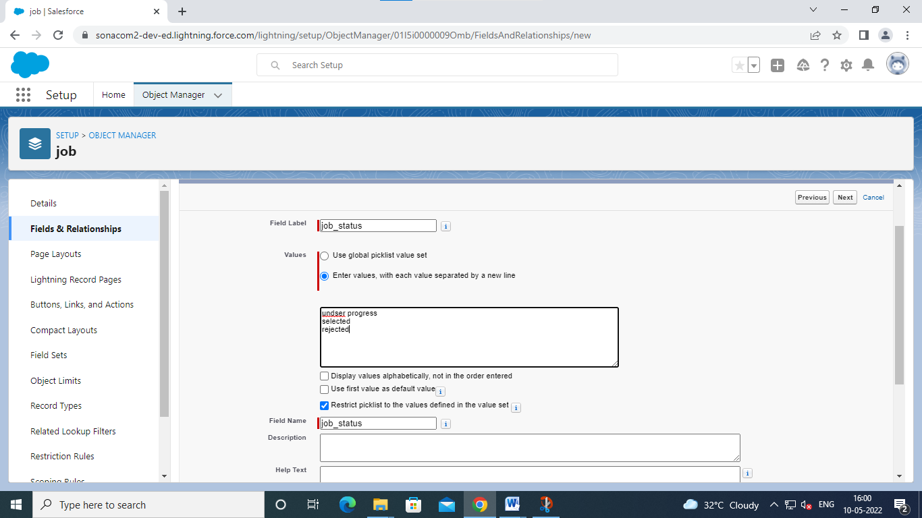

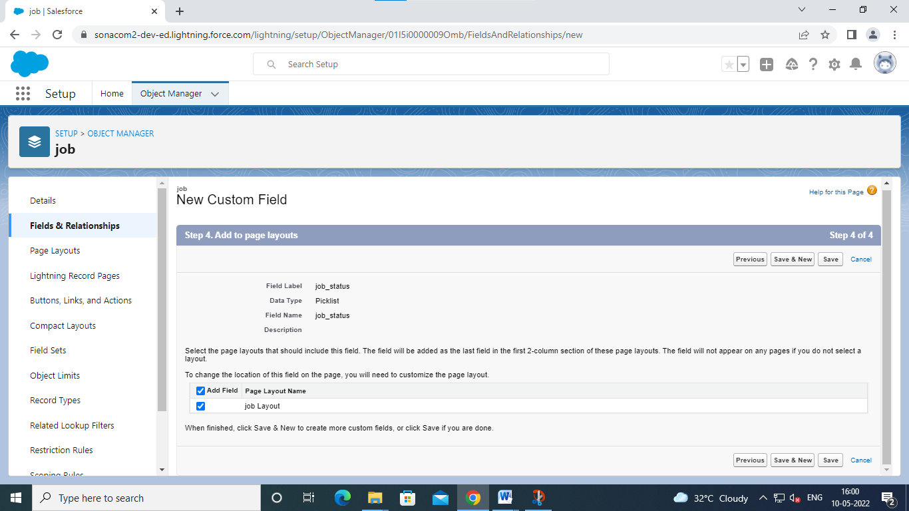

Click save

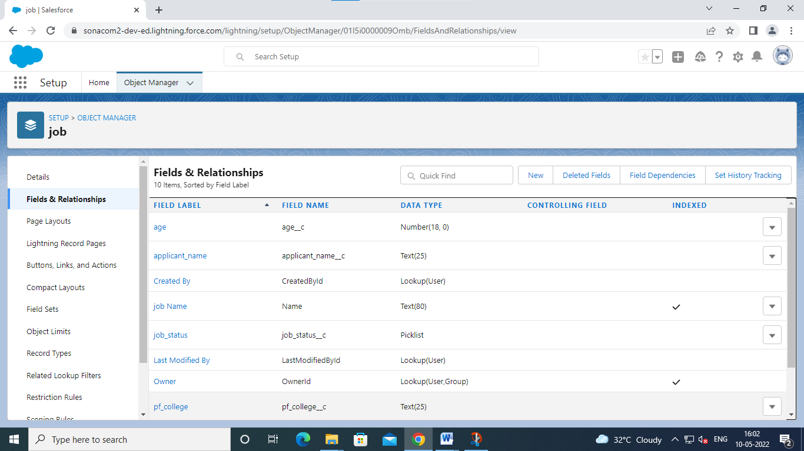

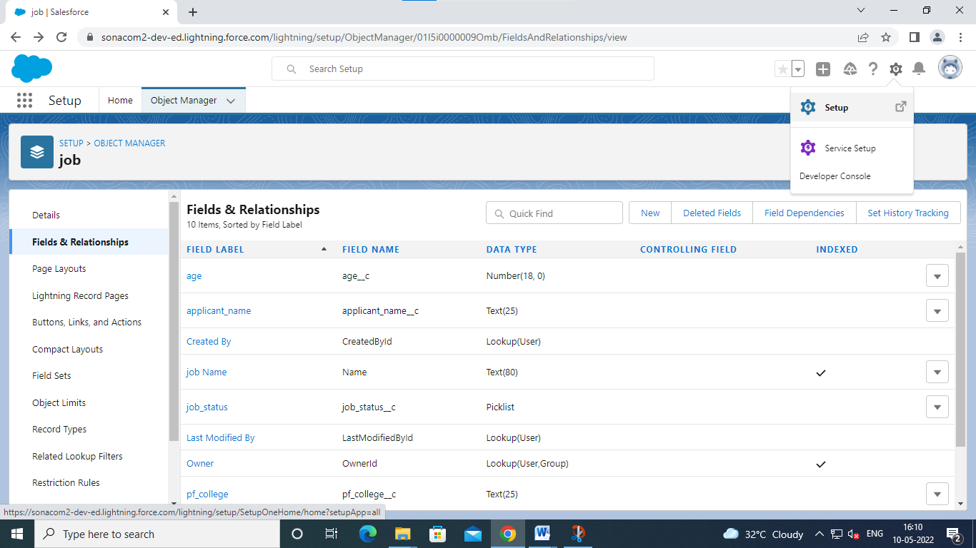

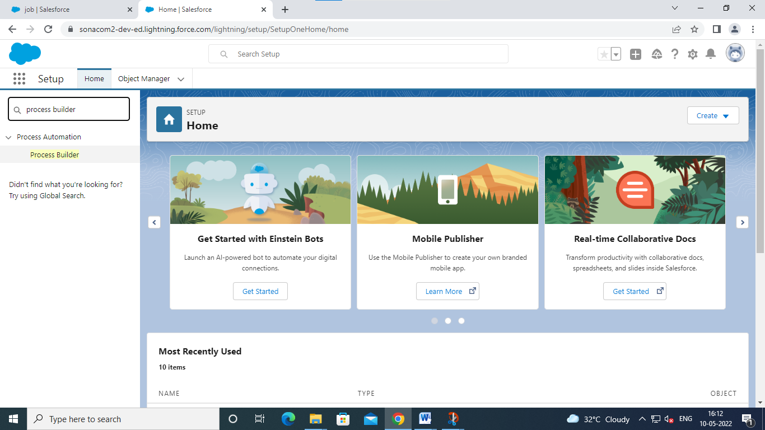

V 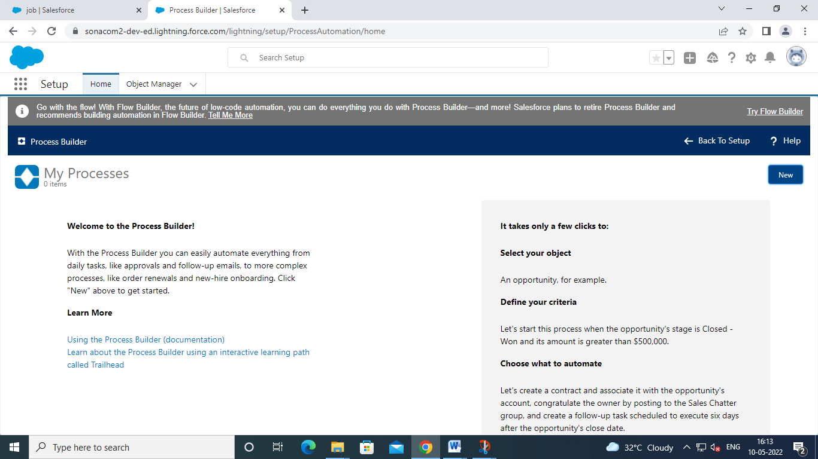

Click new

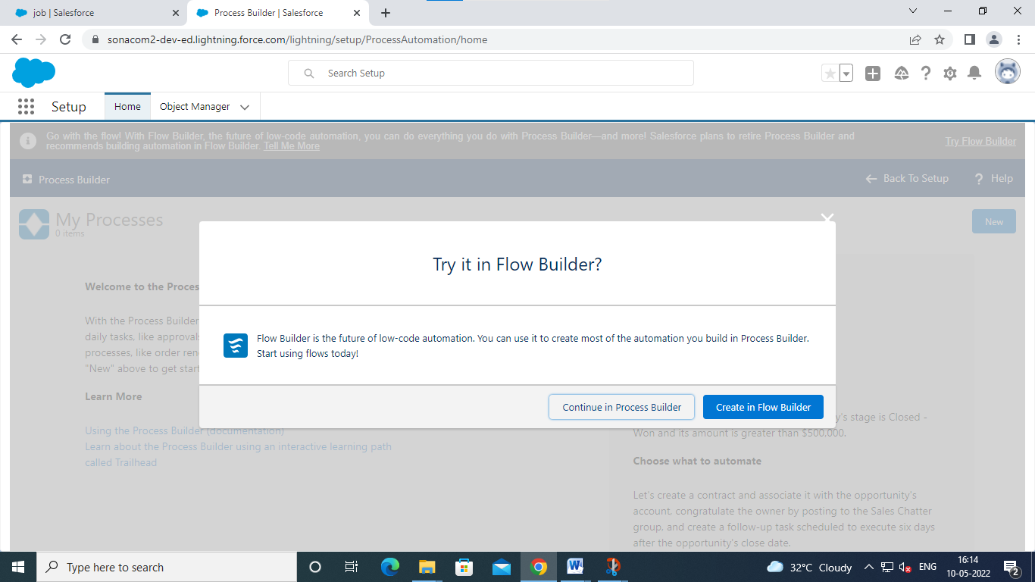

Click continue in process builder

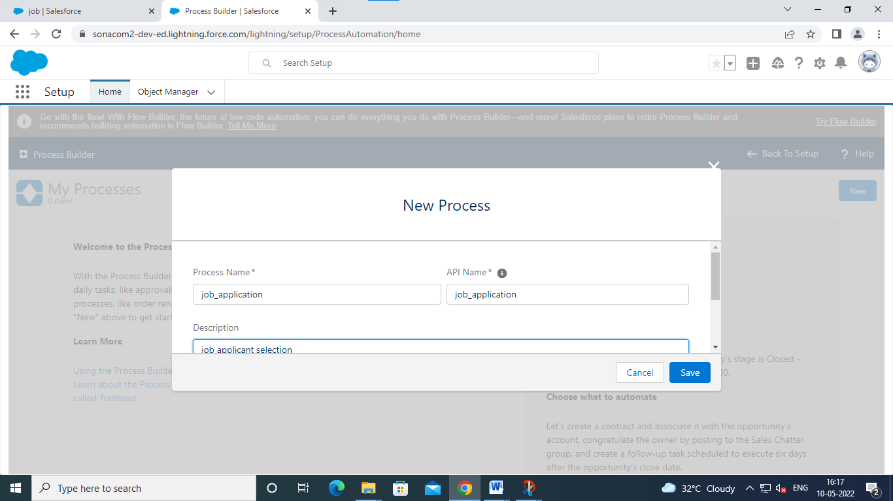

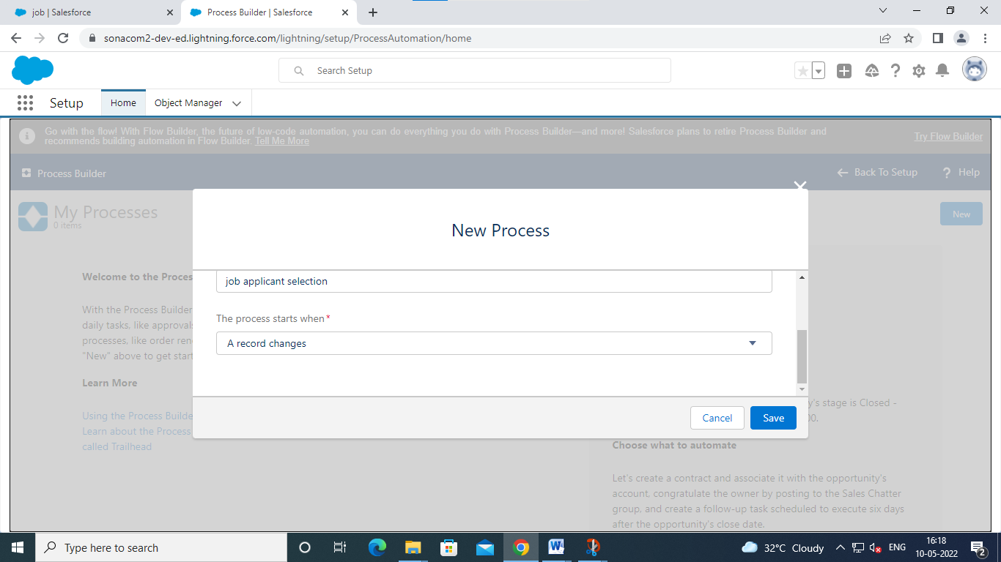

Click save

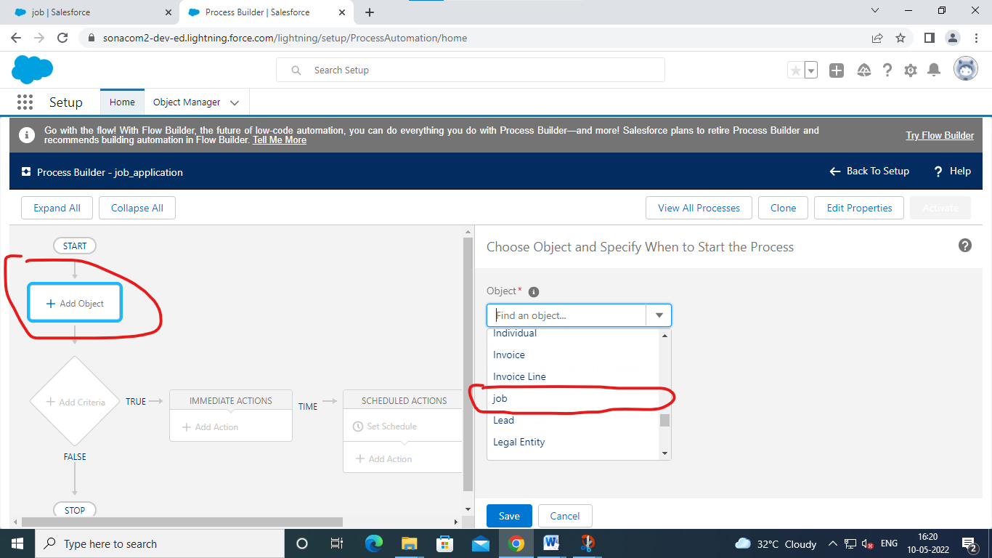

Click add object and choose job and click save

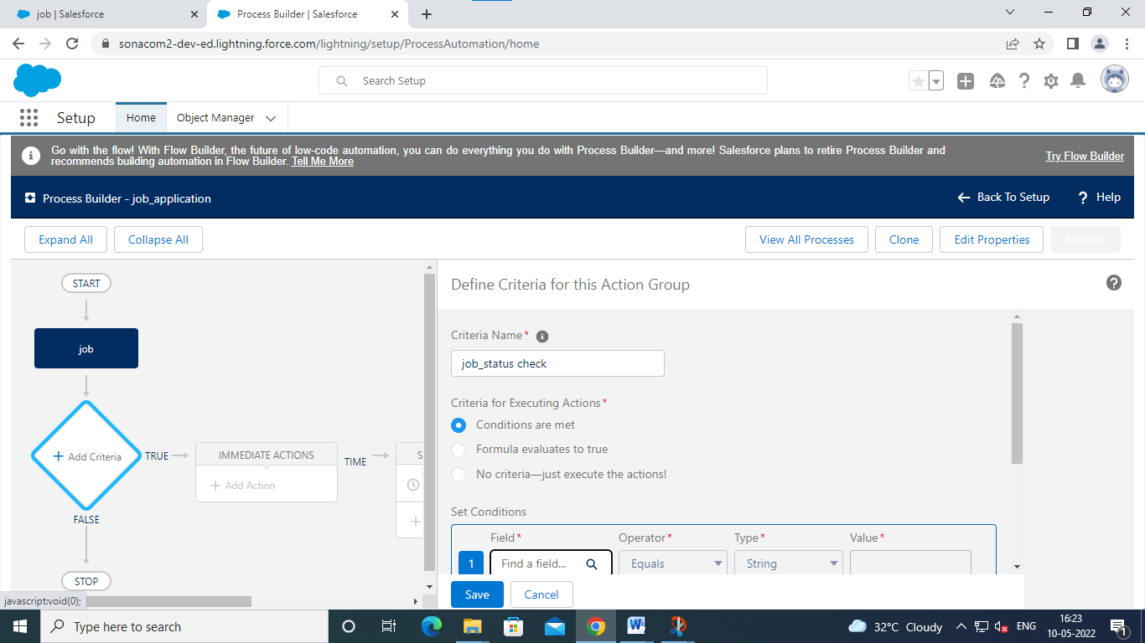

Click field

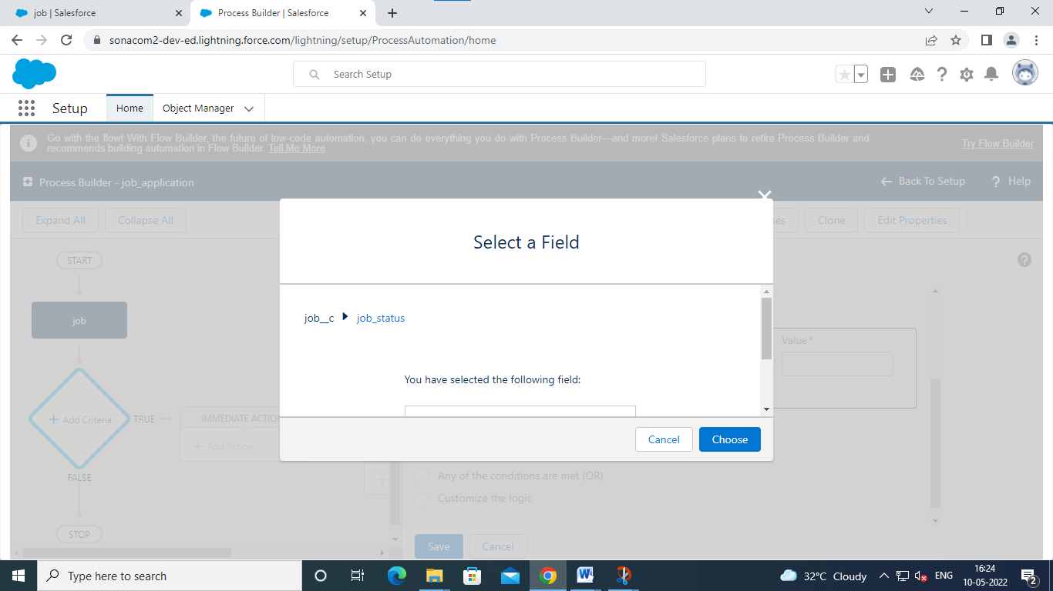

Select job status and click choose

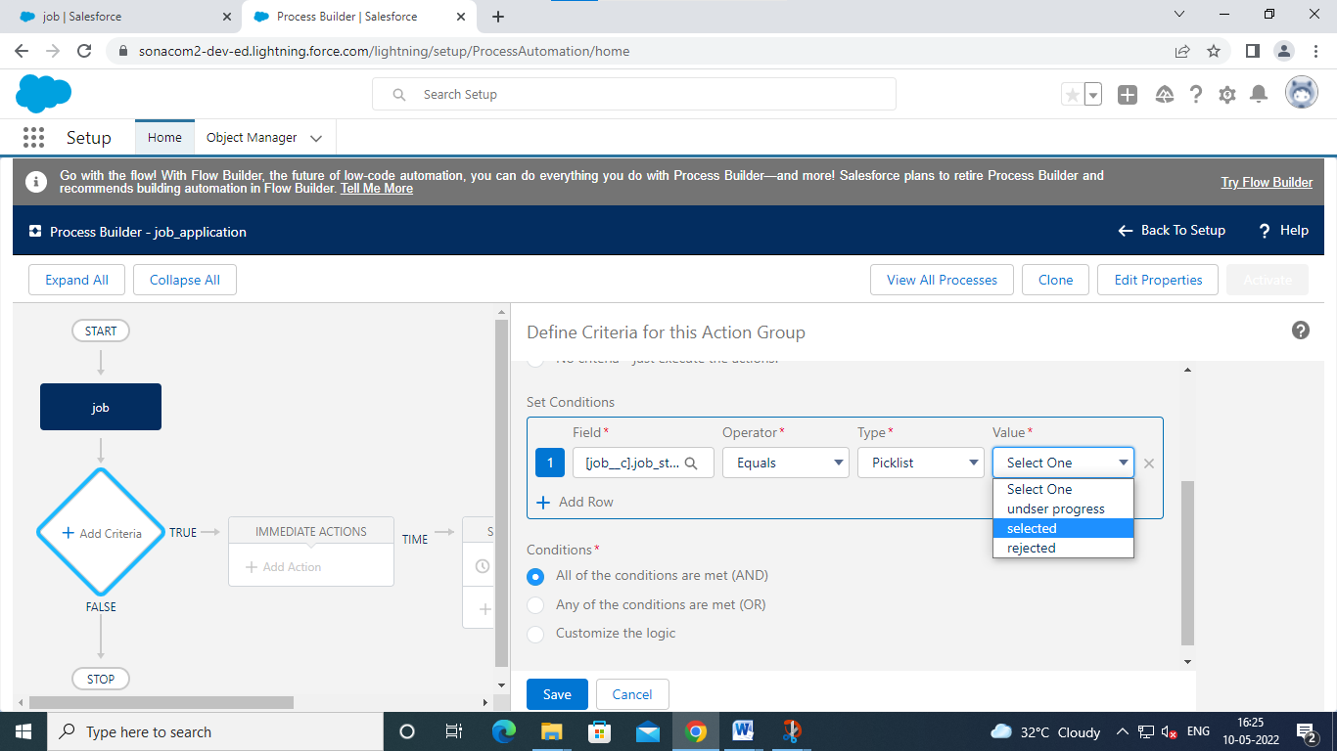

Click selected

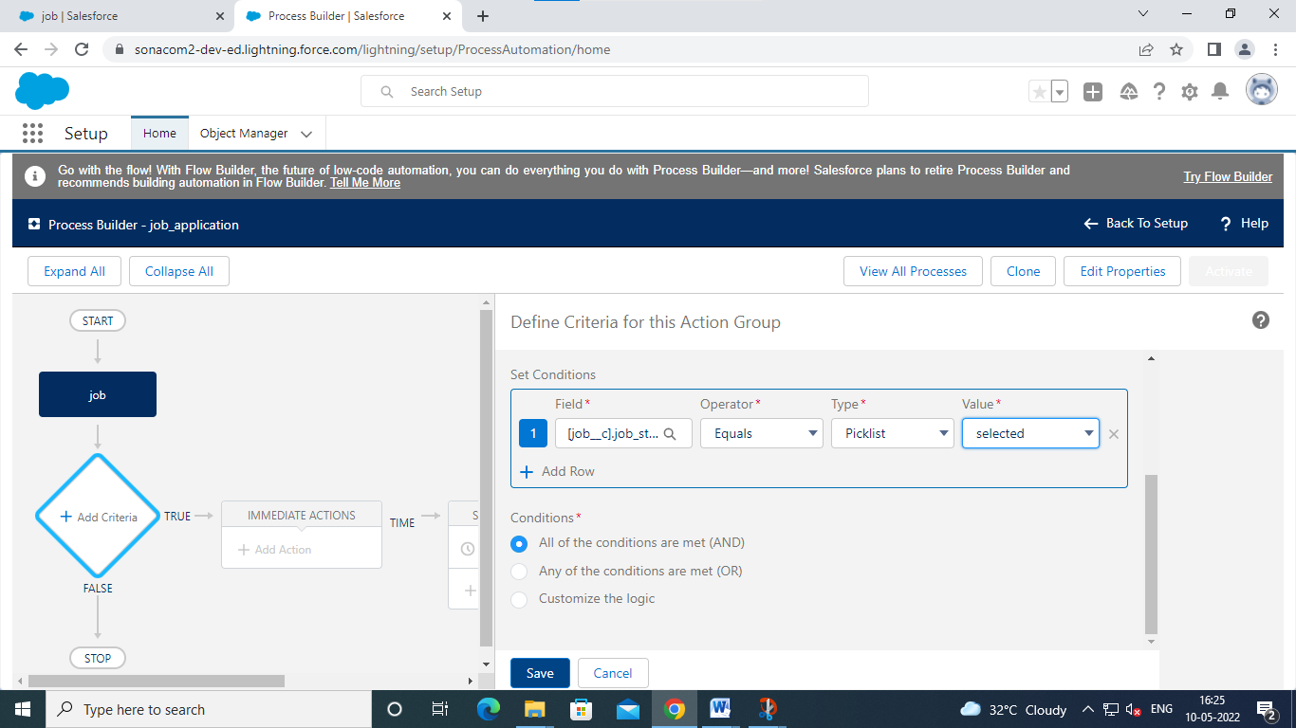

Cick save

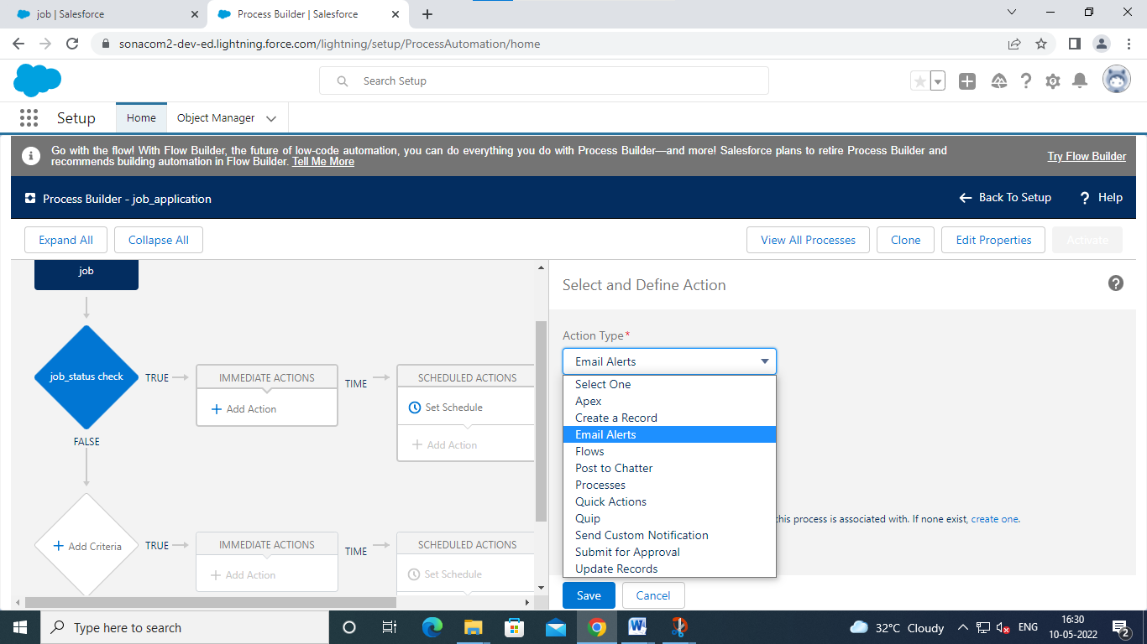

Click ‘immediate action’ and choose ‘action type ‘as ‘email altert’

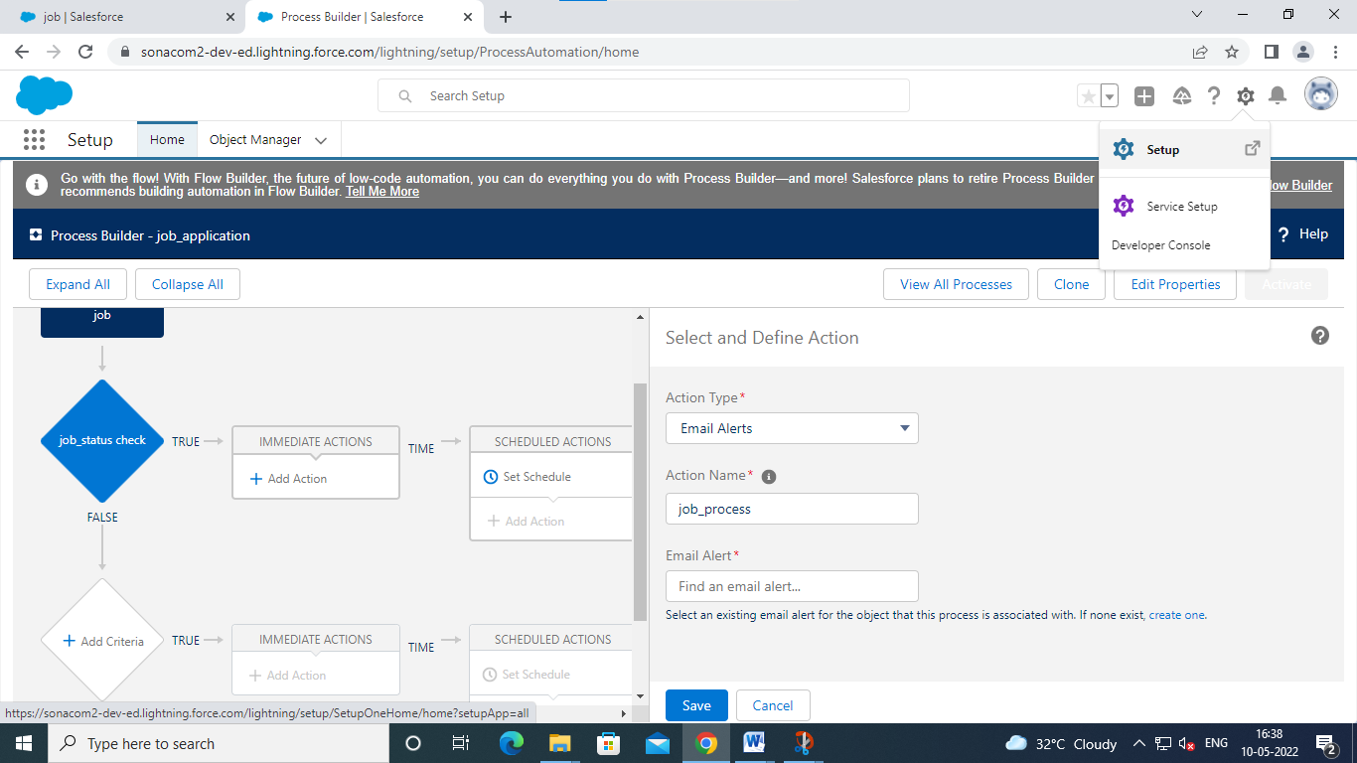

Click setup

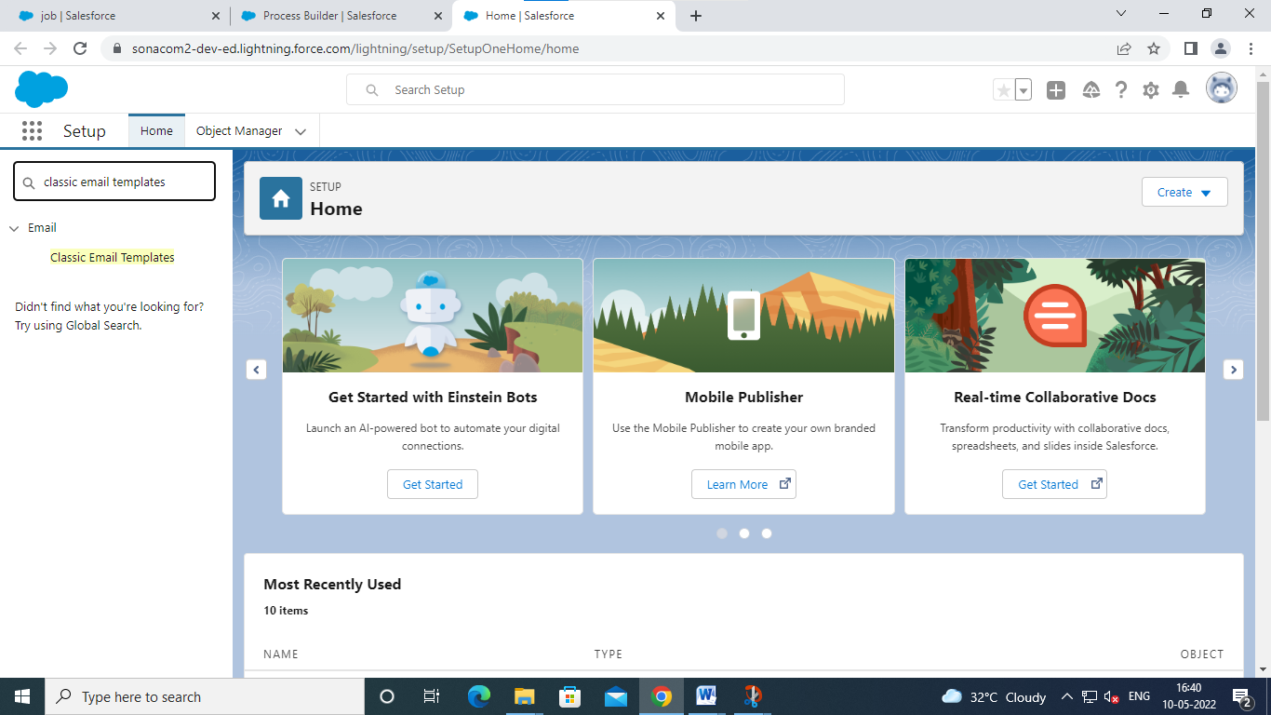

Choose classic email template

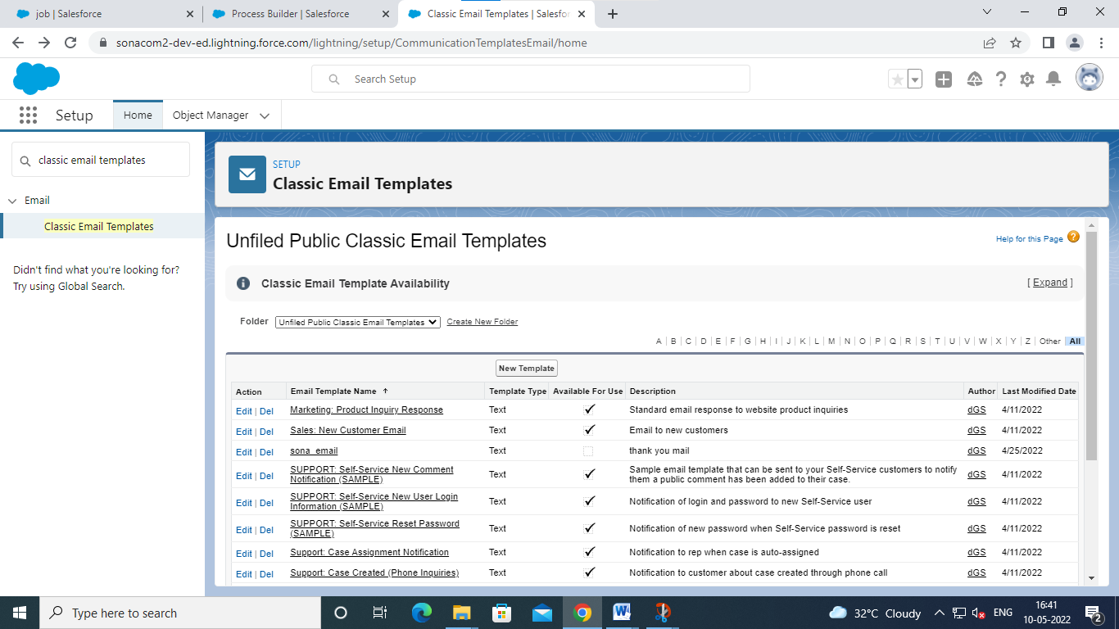

Click new template

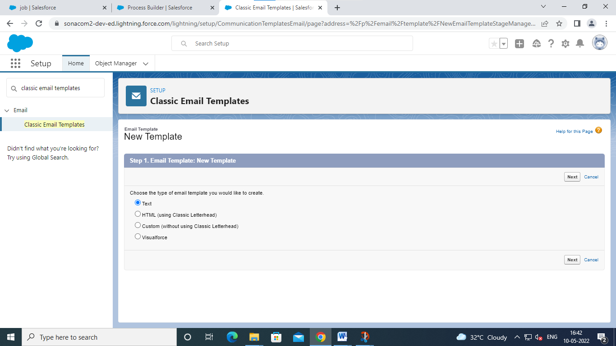

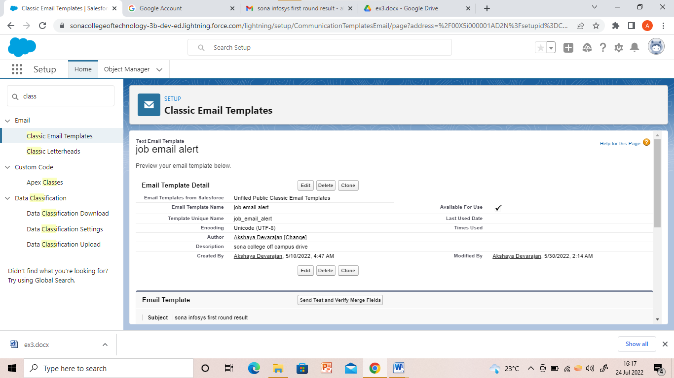

Click save

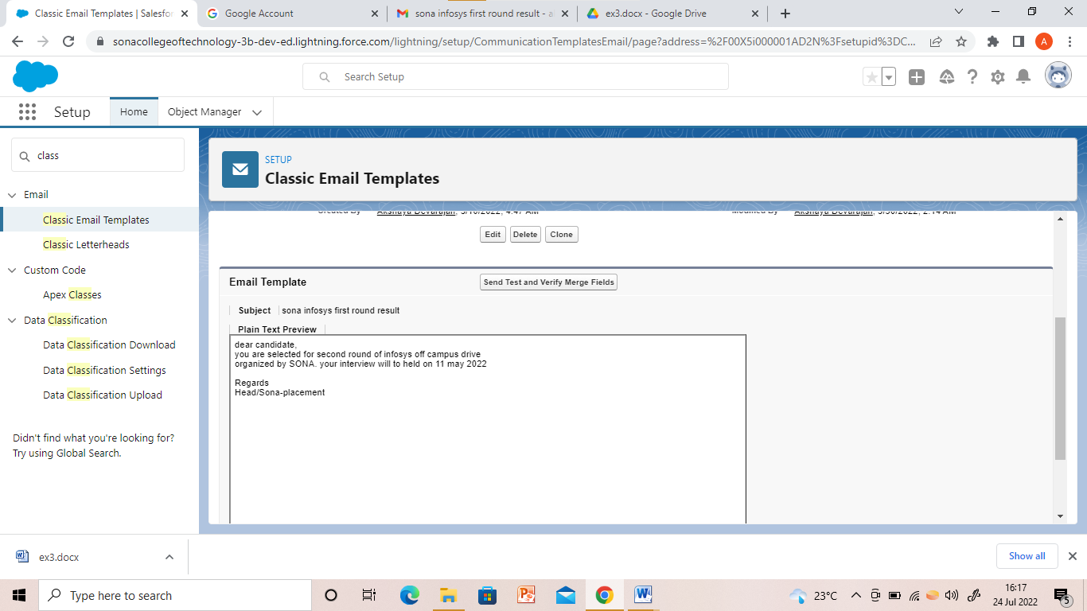

Click setup

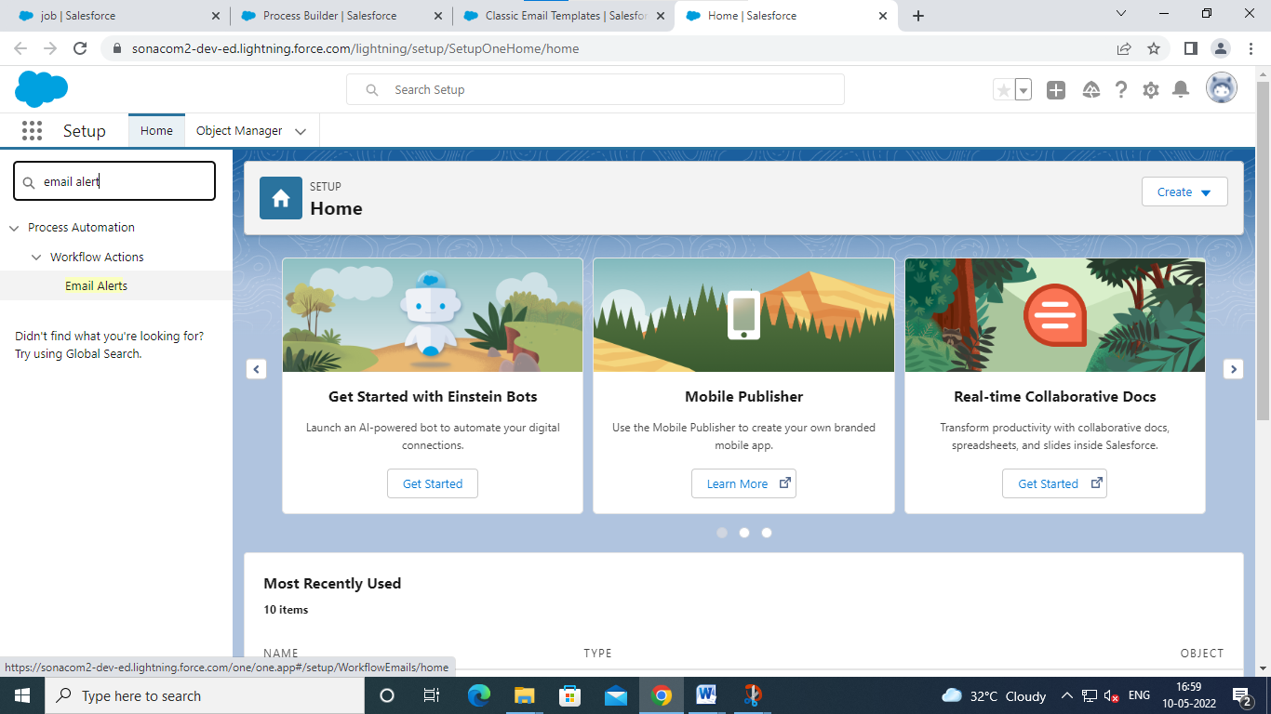

Click email alerts

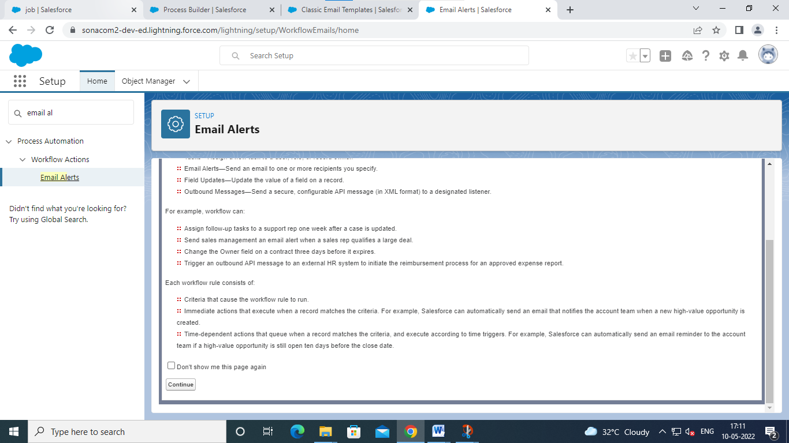

Click continue

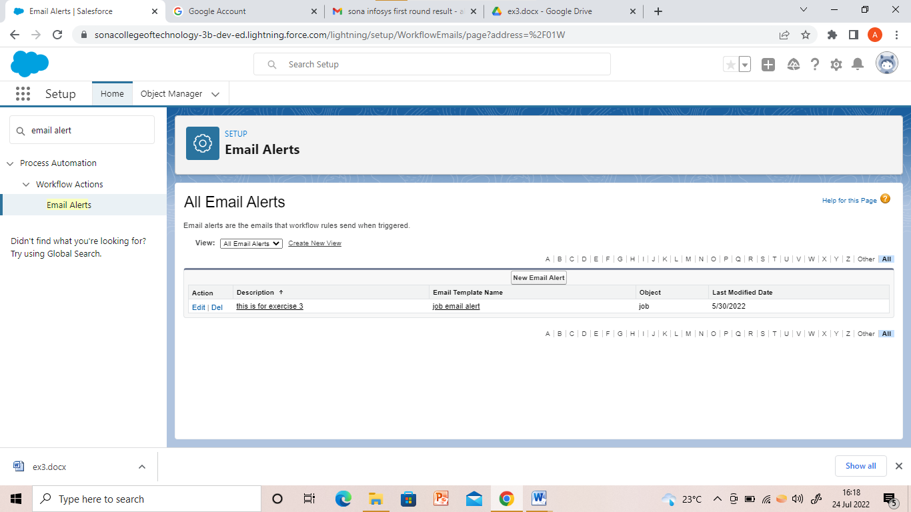

Click new mail alert

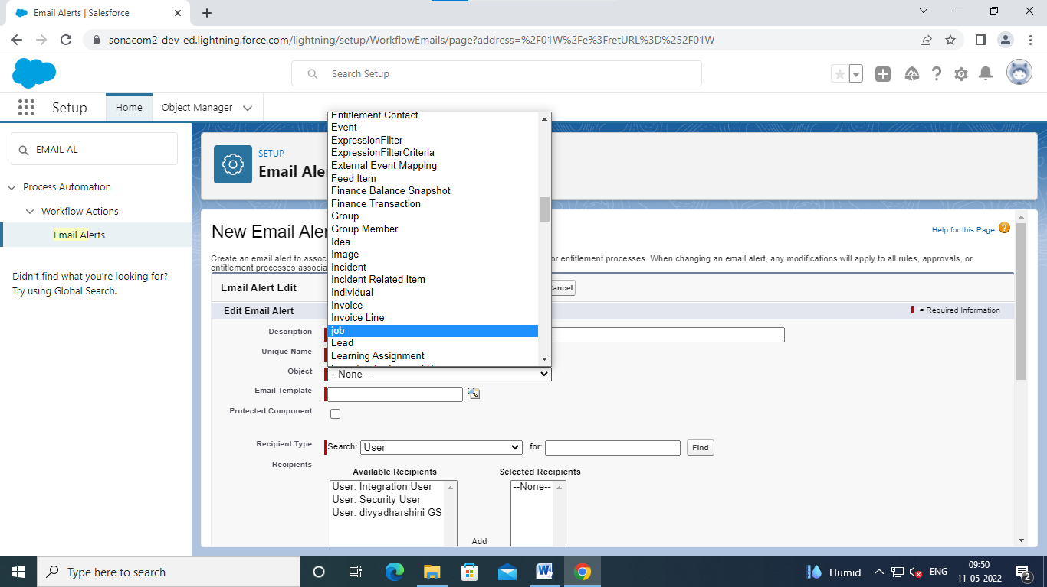

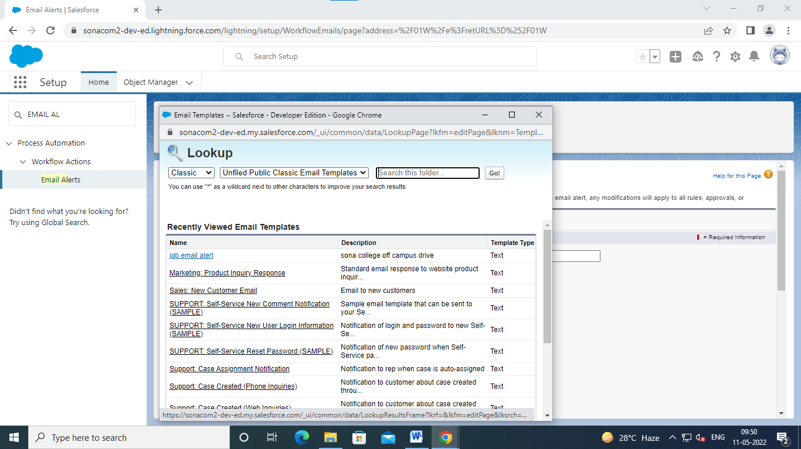

Choose job mail alert

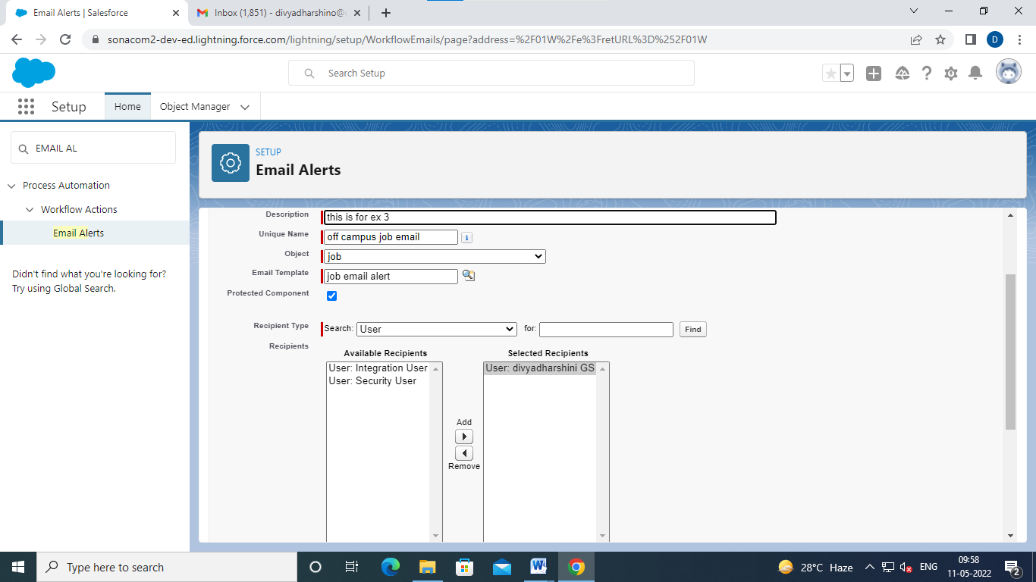

Choose user for recipitant type and user name

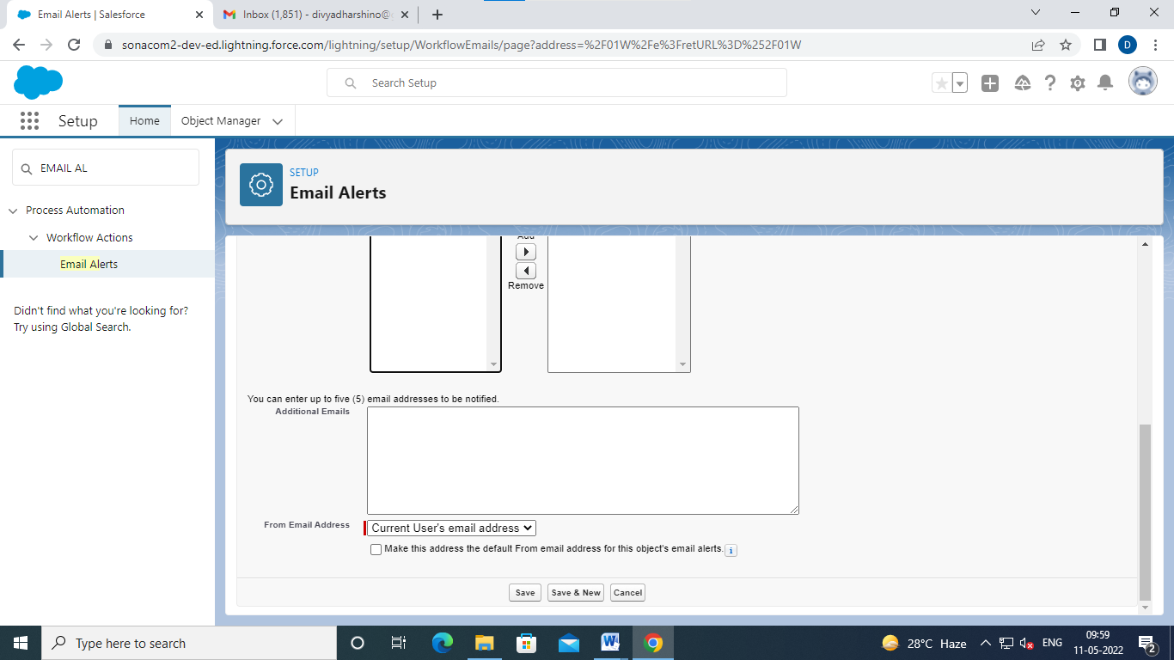

CLICK SAVE

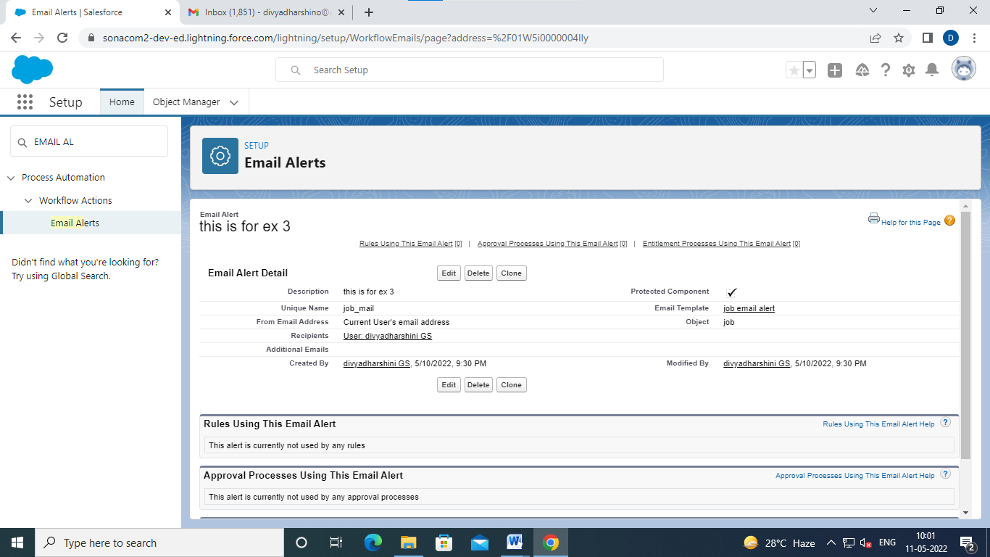

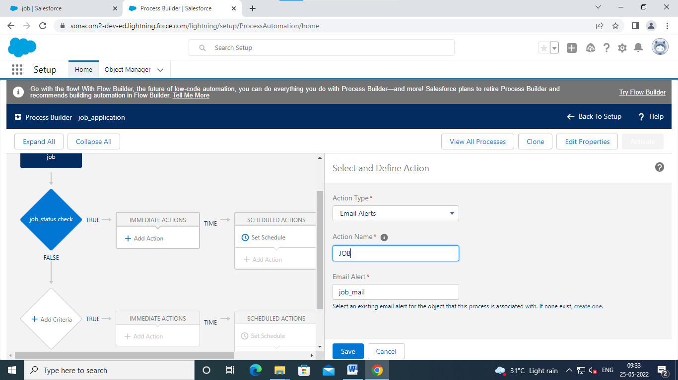

GOTO SETUP AND CLICK PROCESS BULIDER

CHOOSE JOB_APPLICATION

CHOOSE

ACTION TYPE->EMAIL ALERTS

ACTION NAME->JOB

EMAIL ALERT->JOB_MAIL AND CLICK SAVE

AND CLICK ACTIVATE

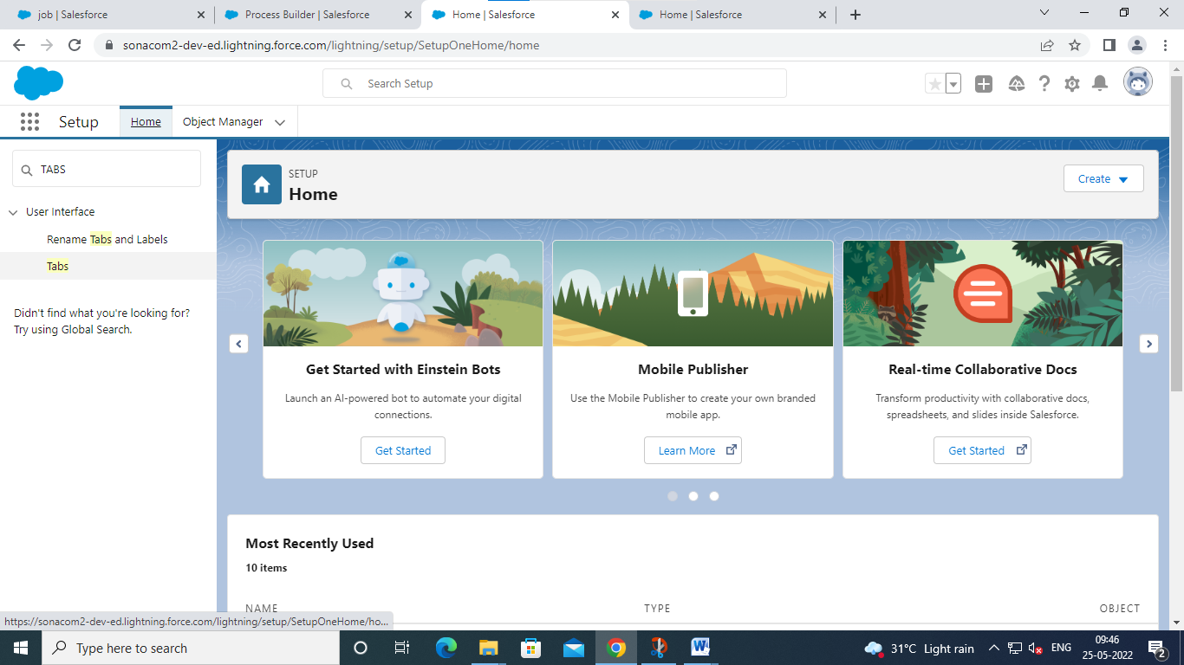

GO TO SETUP AND CLICK TABS IN QUICK FINDER

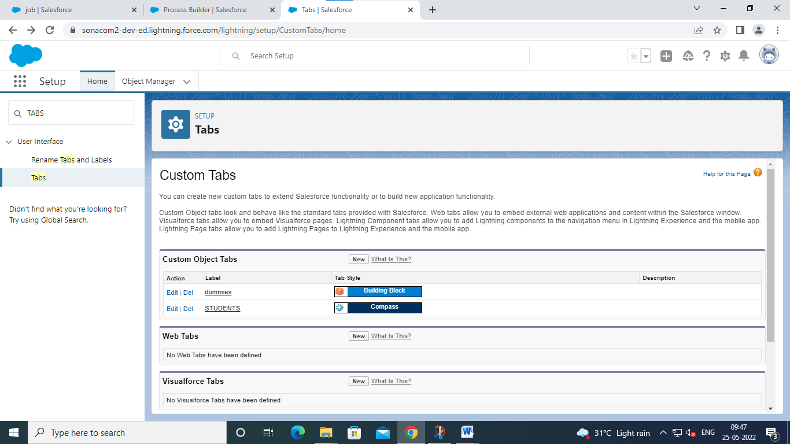

Click new in custom object tabs

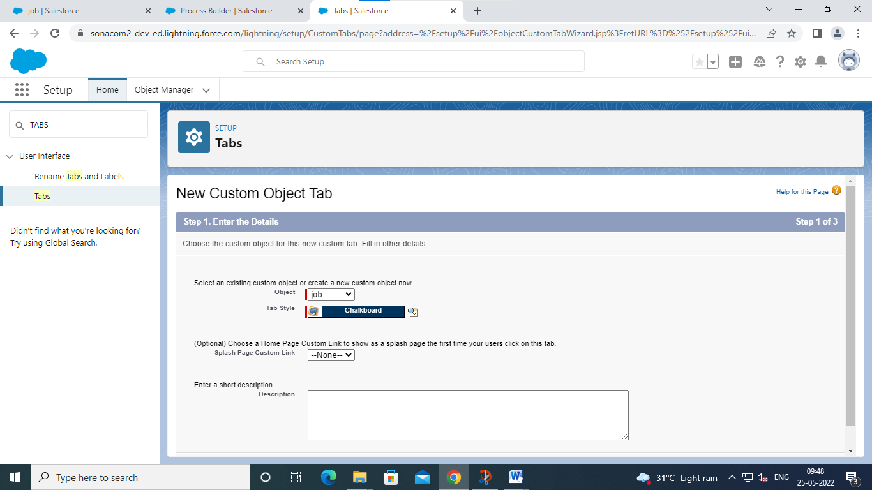

Click next and saves

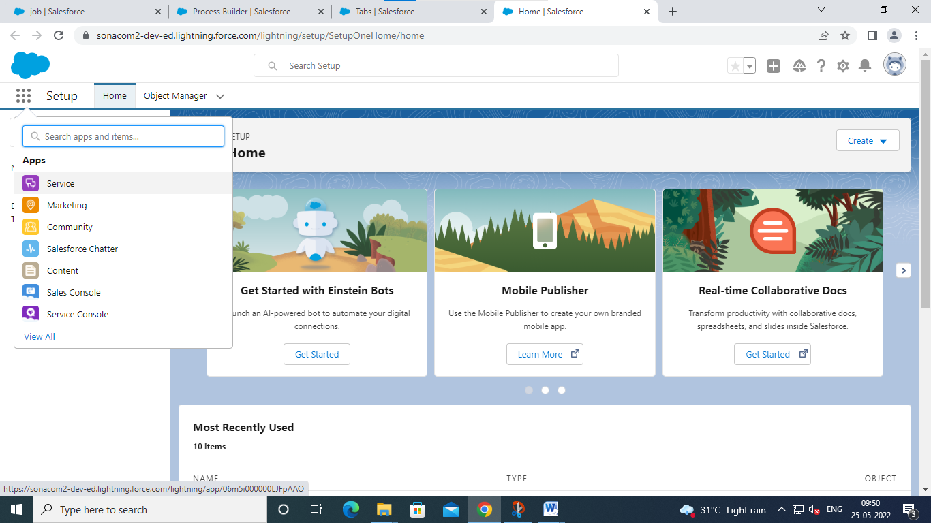

Click service in app launcher

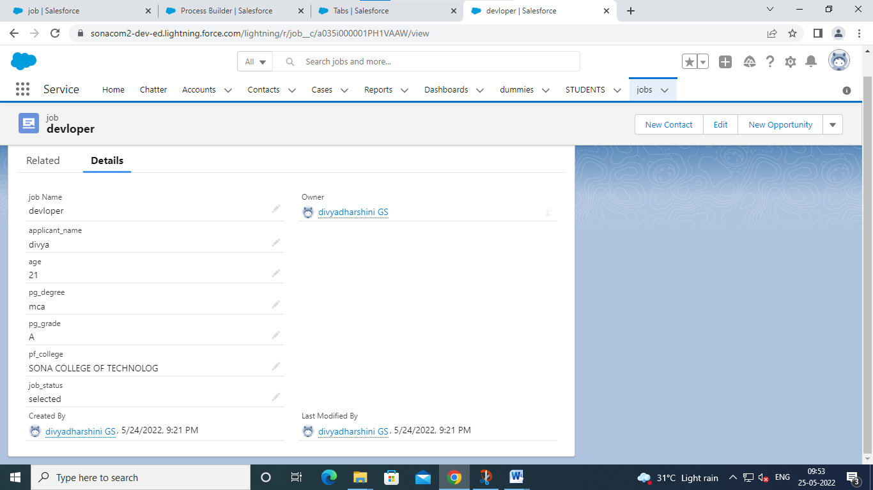

CHOOSE JOBS and CLICK NEW ENTER THE DETAILS AND SAVE

MAIL WILL SENT TO OUR MAILID

